 WHITE SQUAD CRITERIA – JUNE 2025
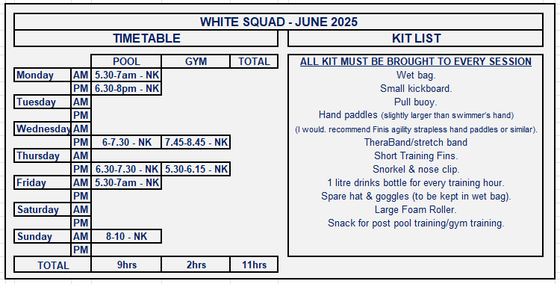
Swimmers in WHITE SQUAD will be within 3 seconds of a 100 or 5 seconds of a 200plus distance for Swim England Spring Regionals for the current year. (Exceptions will be made at the discretion of the Head Coach).

There are SIX swimming sessions available to all WHITE SQUAD swimmers, totalling 9 hours with pre and post pool land sessions and 2 gym sessions. (swimmers 11 years and under are not expected to attend gym sessions until they are 12 years old)
All swimmers are expected to be on time and MUST ARRIVE 15minutes before the START of the swim session and carry out a pre-pool land warm up at sessions where there is no gym session beforehand. At sessions where there is a gym session, swimmers must arrive a minimum of 10 minutes before the start of the session.
Swimmers WILL BE refused entry to establish discipline and show respect to other squad members. All swimmers must speak to the Squad Coach taking the session if they are late.
All swimmers will carry out a 15-minute post pool land stretch off using their foam rollers, after each training session.
Performing the above pre and post pool land warm up and stretch offs will reduce the risk of injury once they are in the pool and prevent muscle soreness post pool swimming.
Swimmers with short training costumes must wear drag shorts/shorts on top of the training suits for all land sessions on the poolside.
When attending the land sessions with the qualified instructor, all swimmers must wear appropriate gym clothing and footwear with swimsuits beneath to reduce wasted time from gym to pool session.
NO CROCS / SLIDERS / INAPPROPIATE FOOTWEAR, WILL BE ALLOWED – Any swimmer that arrives with the incorrect attire will not be allowed to participate in the session.
It is advised for swimmers to shower before entering the pool on the days when the swim session takes place directly after the gym sessions.

Squad movements will take place three times per year, (roughly October/November, February, and June). To move to YELLOW SQUAD swimmers must attend all available sessions, a minimum of one midweek AM swim session and meet the above criteria.
Swimmers must attend both long and short course competitions regularly. If a swimmer is not attending or struggling with sessions, a meeting to discuss their progress will be arranged to discuss a move to a more appropriate squad.

Pauline Gourley
Head Coach
Lincoln Vulcans SC - June 2025

