 ORANGE SQUAD CRITERIA – JUNE 2025
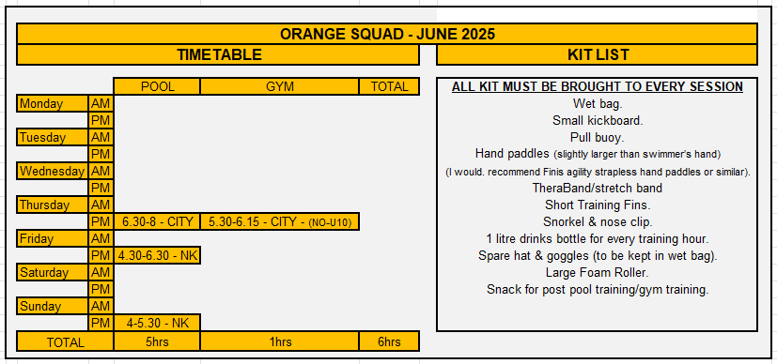

Swimmers in ORANGE SQUAD will have transitioned either from a Learn to Swim programme or from COMPETITIVE DEVELOPMENT SQUAD. Swimmers will be able to swim a minimum of 100 meters without stopping and 50metres of each of the four competitive strokes.
Swimmers will be actively working towards gaining a Lincolnshire ASA County qualifying time. Swimmers in this squad will have passed their Competitive Dive award test and will be expected to take part in club and external competitions

There are a total of THREE swimming sessions totalling 5 hours, available to all ORANGE SQUAD with ten minutes pre and post pool land sessions at every session. There is an additional gym session for those who are 10+ at CITY on a Thursday with a qualified instructor. This session will comprise of body weight exercises focusing on fundamental movements patterns and core strength.
Swimmers must attend all sessions per week. (Unless otherwise agreed with the Head / Squad coach)

All swimmers are expected to be on time and MUST ARRIVE 10 minutes before the START of the swim session and carry out a pre-pool land warm up at sessions where there is no gym session beforehand. At sessions where there is a gym session, swimmers must arrive a minimum of 10 minutes before the start of the session.
Swimmers WILL BE refused entry to establish discipline and show respect to other squad members. All swimmers must speak to the Squad Coach taking the session if they are late.
All swimmers will carry out a 10-minute post pool land stretch off using their foam rollers, after each training session.
Performing the above pre and post pool land warm up and stretch offs will reduce the risk of injury once they are in the pool and prevent muscle soreness post pool swimming.
Swimmers with short training costumes must wear drag shorts/shorts on top of the training suits for all land sessions on the poolside.
When attending the land sessions with the qualified instructor, all swimmers must wear appropriate gym clothing and footwear with swimsuits beneath to reduce wasted time from gym to pool session.
NO CROCS / SLIDERS / INAPPROPIATE FOOTWEAR, WILL BE ALLOWED – Any swimmer that arrives with the incorrect attire will not be allowed to participate in the session.
It is advised for swimmers to shower before entering the pool on the days when the swim session takes place directly after the gym sessions.

Squad movements will take place three times per year, (roughly October/November, February, and June). Swimmers will move to GREEN SQUAD once all swim sessions are regularly attended and the criteria for that squad is met.
Swimmers must attend both long and short course competitions regularly. If a swimmer is not attending or struggling with sessions, a meeting to discuss their progress will be arranged to discuss a move to a more appropriate squad.

Pauline Gourley
Head Coach
Lincoln Vulcans SC – June 2025

