 GREEN SQUAD CRITERIA – JUNE 2025
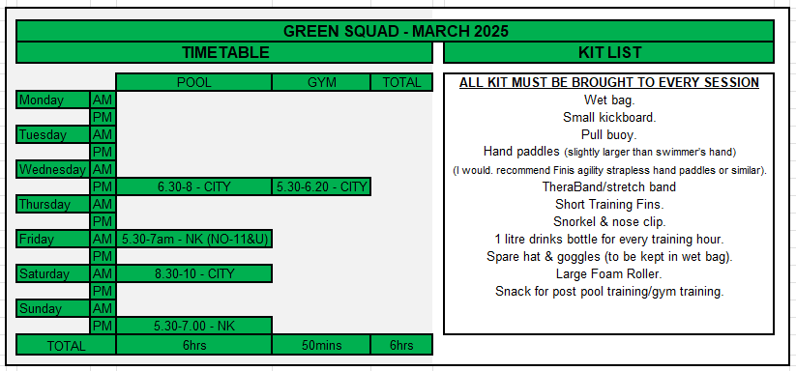

Swimmers in GREEN SQUAD will have or be within 3 seconds of a 100 or 5 seconds of a 200 plus time for the current years Lincolnshire ASA County Qualifying time.

There are a total of FOUR swimming sessions available to GREEN SQUAD swimmers totalling 6 hours and 1 gym session (under 11 not the Fri AM) which will be based around core stability, functional movements and fitness. Swimmers must ensure they have Thera bands and foam rollers with them at every session.
All swimmers are expected to be on time and MUST ARRIVE 15 minutes before the START of the swim session and carry out a pre-pool land warm up at sessions where there is no gym session beforehand. At sessions where there is a gym session, swimmers must arrive a minimum of 10 minutes before the start of the session.
Swimmers WILL BE refused entry to establish discipline and show respect to other squad members. All swimmers must speak to the Squad Coach taking the session if they are late.
All swimmers will carry out a 15-minute post pool land stretch off using their foam rollers, after each training session.
Performing the above pre and post pool land warm up and stretch offs will reduce the risk of injury once they are in the pool and prevent muscle soreness post pool swimming.
Swimmers with short training costumes must wear drag shorts/shorts on top of the training suits for all land sessions on the poolside.
When attending the land sessions with the qualified instructor, all swimmers must wear appropriate gym clothing and footwear with swimsuits beneath to reduce wasted time from gym to pool session.
NO CROCS / SLIDERS / INAPPROPIATE FOOTWEAR, WILL BE ALLOWED – Any swimmer that arrives with the incorrect attire will not be allowed to participate in the session.
It is advised for swimmers to shower before entering the pool on the days when the swim session takes place directly after the gym sessions.

Squad movements will take place three times per year, (roughly October/November, February, and June). Swimmers will move squads once all swim sessions are regularly attended and the criteria for that squad is met.
Swimmers must attend both long and short course competitions regularly. If a swimmer is not attending or struggling with sessions, a meeting to discuss their progress will be arranged to discuss a move to a more appropriate squad.

Pauline Gourley
Head Coach
Lincoln Vulcans SC – June 2025

